Amrit Singh

814994

HIST 120-13

Dr. Meghan Bowe

Jul. 21, 24

Things You Should Know about Gastown

Gastown is a retail and commercial district in Vancouver, British Columbia, bounded by Cordova Street and the waterfront between Richards Street and Main Street. This historic area, where “the original Gastown settlement formed the nucleus for the City of Vancouver and is now a National Historic Site,”[1] is renowned for its charming cobblestone streets, vibrant arts scene, and rich history. However, have you ever wondered how this historical place formed, what makes it a bustling hub today, and why it remains a must-visit destination? Three major aspects illustrate the journey of the formation of Gastown: its early history, its period of decline and revitalization, and its status as a vibrant neighbourhood.

The Gastown area is an important development in the early stages of Vancouver before the first major influx of easterners and lays a foundation for its growth. First settled by the xwməθkwəy̓əm (Musqueam), Tsleil-Waututh, and Sḵwx̱wú7mesh First Nations who harvested its bounty of cedars. Non-Indigenous settlement began in Victoria, with the establishment of Hastings Mill at the foot of Dunlevy Street in 1865. Captain John “Gassy Jack” Deighton opened the area's first saloon in 1867. As the story goes, "Gassy Jack built the settlement's first bar a mere 24 hours after docking his canoe" and "recruited a dozen local mill workers to build the bar in exchange for booze he supplied on-site".[2] The thriving saloon, called the Globe, became "the hub of regional trade and commerce" and led to the formation of Granville Townsite in 1870 and from there, into Gastown.[3] These early beginnings would set the foundation for Gastown to transform from a crude outpost to a rowdy, viable epicentre of commerce and societal life which was vital in Vancouver when it soon sprung up.

Gastown’s period of decline and revitalization showcases a remarkable urban transformation. The area was in extreme decline by the time of the Great Depression, following years-long economic difficulty and a lack of investment; it became known as The Skids – Vancouver's "Skid Row".[4] It was this descent that saw many local businesses close shop and the bustling character of the area disappear. The late 1970s, however, proved to be a crucial year in reclaiming its original state and the movement towards the protection of the heritage. Designated a Provincial Historic Area in 1971 and a National Historic Site of Canada in 2009, historic buildings have been rehabilitated or retrofitted to new commercial businesses alongside cultural venues.[5]

Gastown's reputation as a vibrant neighbourhood is evident in its bustling atmosphere and diverse range of shops that draw both locals and tourists. Recognizable for its historic authenticity merged with contemporary exuberance, the neighbourhood bursts with a cutting-edge ambience where an integrative mix of fashion shops and dining offers infiltrate the streetscape. The above quotation highlights the public appeal of Gastown as, "the Steam Clock is definitely one popular trendy and can easily double most Well-known holiday interest points in Vancouver".[6] This blend of historical architecture and advanced offerings helps keep Gastown central to Vancouver's social landscape, making it a meaningful collection in the overall tapestry that is this city.

In conclusion, the history of Gastown’s transformation from an original Indigenous settlement into one of the vital neighbourhoods is an inspiring story of resilience. Founded by the First Nations and Canadian settlers, such as “Gassy Jack”, the area went into decay in the 1930s. Yet, in the latter part of the 20th century, the revitalization transformed Gastown into a unique fusion of old-time charm and contemporary high energy. It continues to be one of Vancouver’s determined cultural elements, as both Vancouverites and visitors enjoy the distinct character of this special place.

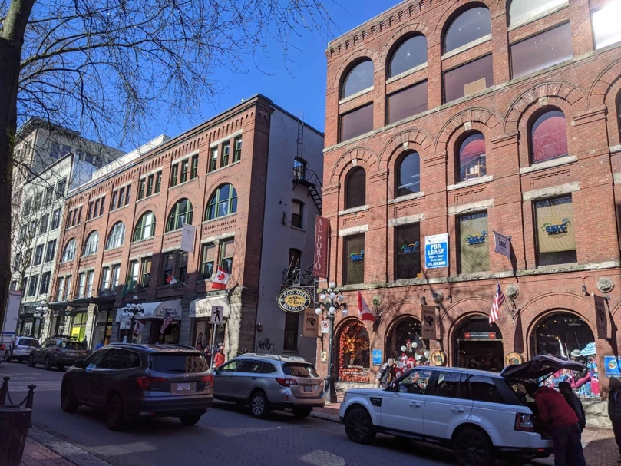

*Heritagesitefinder*. "Gastown." Heritage Site Finder. March 2020.

<https://www.heritagesitefinder.ca/img/asset/bG9jYXRpb25faW1hZ2VzL0lNR18yMDIwMDMxMV8xNDQ5MDctc2NhbGVkLmpwZw==?p=full-webp>.

*Heritagesitefinder*. Street Restoration in Blood Alley Square, 1973. CVA 780-522. Heritage Site Finder. 2020. <https://www.heritagesitefinder.ca/img/asset/bG9jYXRpb25faW1hZ2VzL0NWQS03ODAtNTIyLUJsb29kLUFsbGV5LVNxdWFyZS1hbmQtVHJvdW5jZS1BbGxleS1jb25zdHJ1Y3Rpb24tMTk3My1zY2FsZWQuanBn?p=lg-webp>

Bibliography

Russwurm, Lani. “Gastown.” *The Canadian Encyclopedia*. Historica Canada. Published October 27, 2017. Last edited November 21, 2017. [https://www.thecanadianencyclopedia.ca/en/article/gastown.](https://www.thecanadianencyclopedia.ca/en/article/gastown)

Lambert, Barbara Ann. “Gastown Memories: Discovered in an Old Steamer Trunk.” *British Columbia History* 49, no. 4 (Winter 2016): 33–35. ISSN 17107881. Accession Number 120531988.

*Heritagesitefinder*. “Gastown Historic Area.” Accessed July 20, 2024. <https://www.heritagesitefinder.ca/area/gastown-historic-area#:~:text=The%20majority%20of%20the%20architecture,construction%20and%20varying%20building%20height>.

Pitargue, Ali. “Gastown: A History.” December 2, 2018. *YouTube*. <https://www.youtube.com/watch?v=UphyjxfPP6Q>.

1. Lani Russwurm, “Gastown,” *The Canadian Encyclopedia* (Historica Canada: 2017), para. 1.
2. Ali Pitargue, “Gastown: A History,” December 2, 2018, *YouTube*, 0:24-0:39.
3. Ali Pitargue, “Gastown: A History,” December 2, 2018, *YouTube*, 0:45-0:50.
4. *Heritagesitefinder*, “Gastown Historic Area,” accessed July 20, 2024, para. 7.
5. *Heritagesitefinder*, “Gastown Historic Area,” accessed July 20, 2024, para. 13.
6. Barbara Ann Lambert, Gastown Memories Discovered in an Old Steamer Trunk*, British Columbia History* 49, no. 4 (Winter 2016): para. 1.